1. Alampalli, Shravani
2. Team D – Phoenix
3. **Client**: Dr. Michael Oudshoorn
4. **Project** - Slack/Hipchat collaboration tool
5. **Role** – Issues Management.
6. **ITERATION PLAN:**

I have been assigned the role of issues management for this project. I am responsible for tracking all the issues in the project and ensures that they are resolved on time. I think 12-16% of work is completed by me, by having a client meeting, and on gathered requirements. Until now project progress is on track and going well. We got an idea about few requirements on which our team divided the tasks. My part is to create use case and test case for shared calendar.

**What accomplishments you made last week.**

We had few client meetings regarding requirements and also regarding issues for the ideas which we have. After meet with client we decided the domain in “Project Management Collaboration Tools”. We had two team meetings in order to get a detailed idea about the use cases and test cases for all the requirements, after meeting the client. In team meeting we came across the use cases and test cases for requirements document. And divided the tasks in another team meeting according to everyone’s strengths. I came across the use case and test case for shared calendar which took time nearly 16 hours. Not only that I also worked for mid-term presentation and mid-term submission. Mainly I worked on Gantt charts and prototypes along with one of my team member. So, overly I worked for 40 hours in these week.

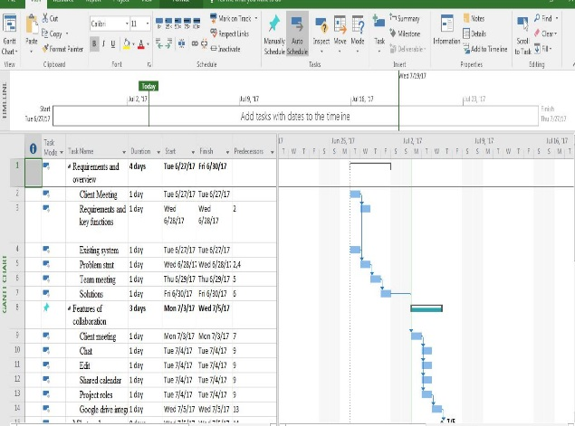 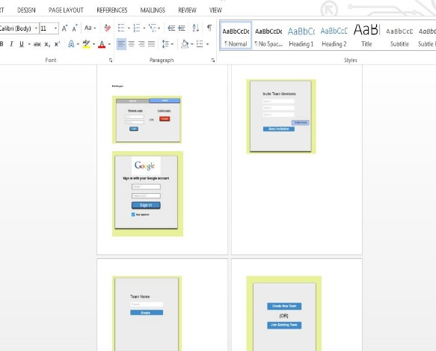

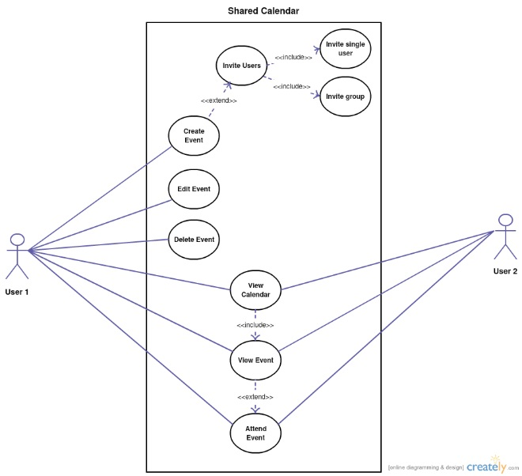

**Tasks to complete this week:**

1. Some more client meetings and get to know more about the requirements.
2. Team meetings in order to decide requirement documents and also to start and divide final doc.
3. I’m going to work on data management plan which is place a key role in our project. Data management plan is used for what, where and when. Can it possible without database, if so how?
4. Make sure to push the documentation to Github repository.

**Any unresolved issues or blockers that keep you from making progress.**

No unresolved issues or blockers that effect my progress in these week.

1. **What is the riskiest component under development?**

Writing test cases for the requirements is the riskiest component for up to now. And I think there is still some test cases needed to be identified.

1. **What active efforts are most critical for client acceptance or GDP completion?**

Understanding the requirements of client and working on it to produce a required collaboration tool is very critical which is a final product. Satisfying client based on his requirements is also a critical thing.